Titration errors
All measurements have associated errors and uncertainties.
It is important to understand these uncertainties and to know the maximum error/uncertainty that a measurement can tolerate.
The variability of a measurement cannot be determined from a single measurement, therefore multiple measurements (replicates) are made to check reproducibility.
Precision = reproducibility of a measurement
The replicate measurements are very rarely exactly the same. Therefore, a central value is taken as the best estimate.
Accuracy = closeness of a measurement to the true or accepted value
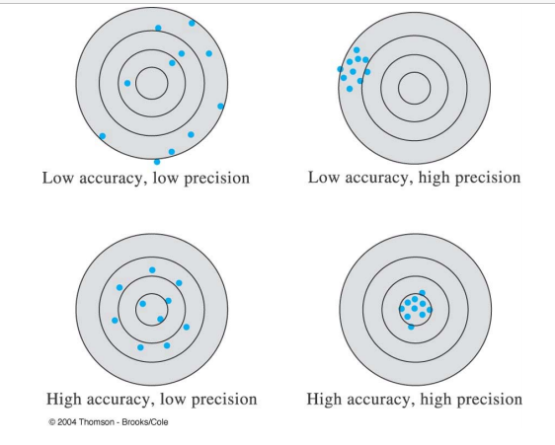

Types of errors:
Random (or in determinant): data are scattered more or less symmetrically about the central value (precision reflects random error)
Systematic (or determinant): constant deviation (in sign and magnitude) from central value (accuracy affected by systematic error)
systematic errors lead to bias in results whereby a series of replicate measurements may all be high or low.

Systematic errors
A systematic error is an error that is constant or drifting slightly and is due to a consistent mistake made during the analysis.
Typical systematic errors in titration analyses include:
• Differing or incorrect analytical method compared to that used to determine the ‘true’ value
• Incorrect calculation formulas
• Sampling errors
• Sample size errors e.g. due to a constant weighing error
• Incorrect titrant concentration
• False or missing blank value
• Incorrect or missing sensor adjustment
• Too high titration speed for the chemical reaction
• Too high titration speed for the electrode response Once the source of a systematic error is identified it is usually easy to correct for these errors.
Random errors
A random error is a component of the overall error that varies in an unpredictable fashion. It is usually difficult to identify these errors.
Typical sources of random errors include:
• Poor sample handling
• Inadequate equipment e.g. too low balance resolution, wrong grade of glassware etc.
• Incorrect method parameters e.g. too large increments, insufficient waiting time between increments.
• Bubbles in burette tubes
• Ineffective rinsing between samples
• Lack of operator training
• Inadequate environmental conditions e.g. temperature and humidity fluctuations
If the source of a random error cannot be identified, then the only solution is to increase the number of replicates in order to get a more trustworthy mean value. This generally leads to waste of sample, reagents and time

